**GEN AI ASSIGNMENT -3**

Building a complete HTML + JavaScript frontend for student registration and login using Supabase

Log in into loveable

Then after login into Lovable then connect it with supabase

In supabase you need to create a project then it should connect with lovable

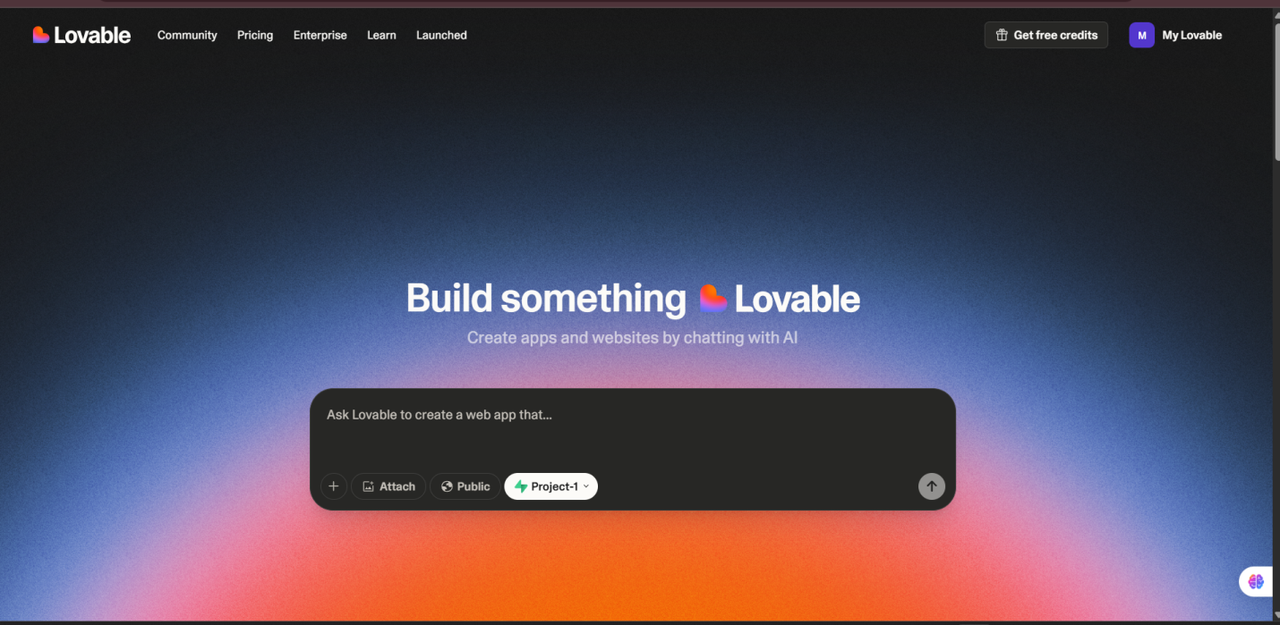

In lovable to create student registration and login for that we need to give accurate prompt because

In lovable we have limited tokens so the prompt should be accurate.

While generating the log in page we may face issues but by giving more accurate prompts it will give our out put

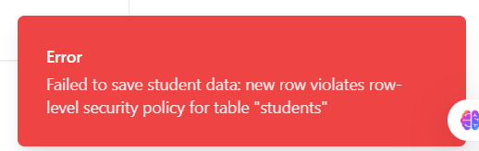

After that it will generate a log in page for student Registration

We need to sign up first so that the data will be stored in backend

While sign up also we may get few issues like,

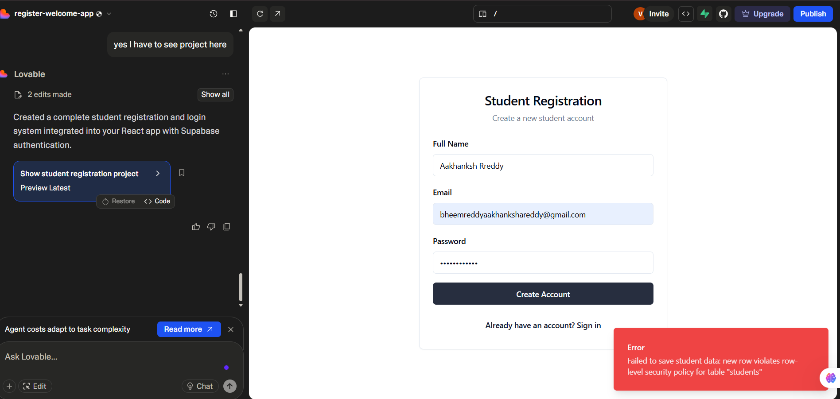

But after changing our email and we need try after 1 minute,

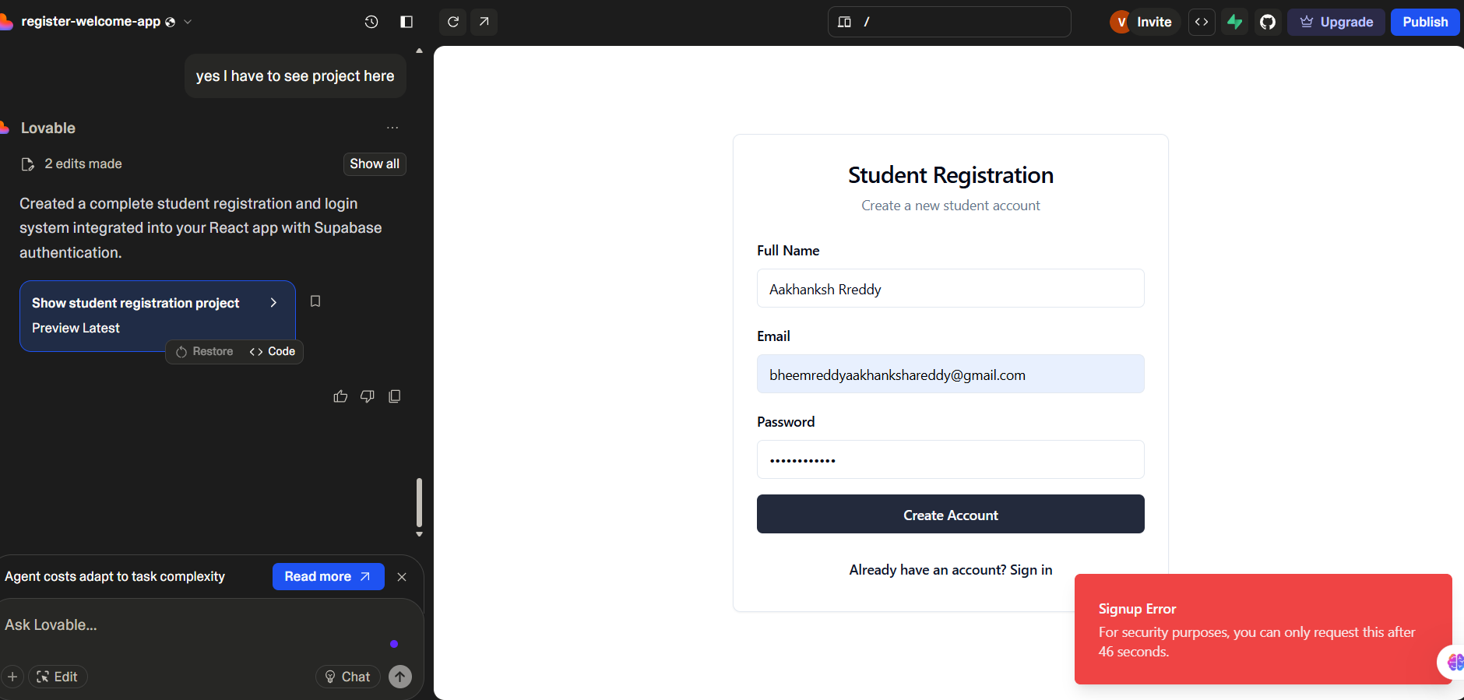

Then we will be able to access that student data saved successful

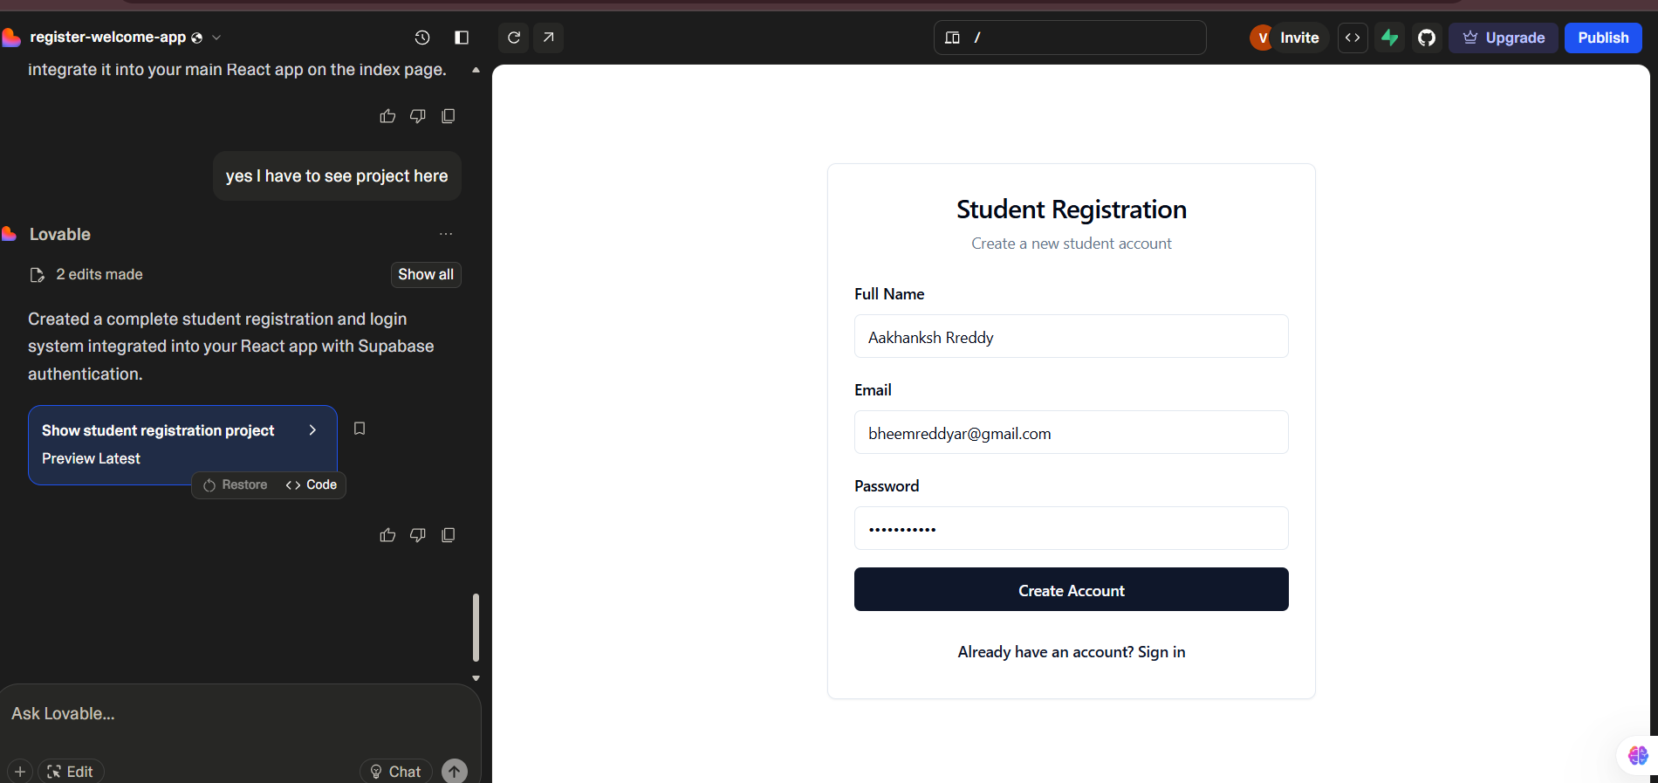

After sign up we will be getting confirmation mail to our mail for sign up

So if we click on confirm your mail

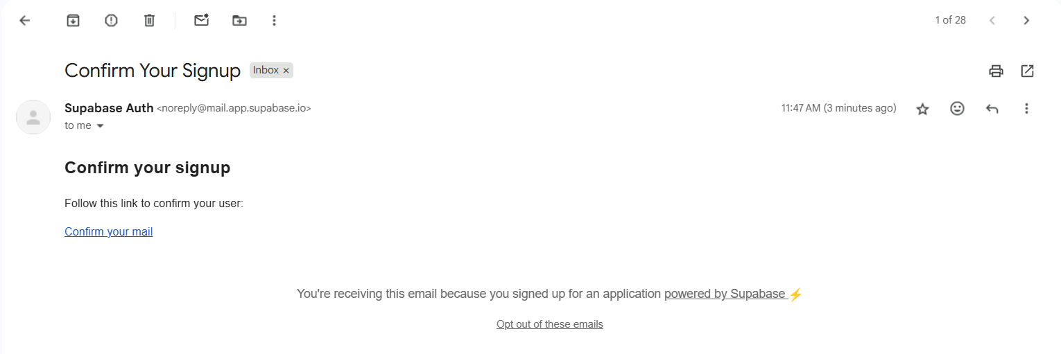

We will get data stored in backend

